**Study of molecular effect of Interluekin-1beta +3953 (IL-1B+3953) gene polymorphism on concentration of their product level in saliva and serum in periodontitis subjects in Babylon province**

**Ahmed Zuhair Al-Waeli 1, Frial Jameel Abd** 2**,**

**Ali Hmood Al-Saadi** 3**, Azhar Omran Al-Zahab** 4**, Zainab Muhi Hameed** 5 **and Alaa Saad Karkosh** 6

1,2,3,4 **Iraq/Babylon university, Department of Biology/ Collage of science.**

5 **Iraq/Babylon university, Department of periodontal/ Collage of Dentistry**

6 **Iraq/ Green university of Al-Qasim /Department of field of crop/ collage of Agriculture**.

**Abstract**

This study aimed to study the molecular effect of Interluekin-1beta(IL-1β +3953)on concentration of their product in saliva and serum**.** A patients –healthy study was conducted between February 2015- May 2015 and it included 100 Iraqi patients from Babylon Province with periodontitis and with the 30 number of healthy population and it was conducted in Faculty of Dentistry**.**

Genetic analysis involved studying gene polymorphism of IL-1β +3953 by using PCR-RFLP**,** and numbers and types of bacteria associated with the subjects , the study was showed that the number of aerobic bacteria in patients were 2.8 X 105 CFU/ml compare with healthy 3.1X 103 CFU/ml this difference was significant *P*= 0.000 ,while the number anaerobic in patients bacteria were 1.6X104 CFU/ml compare with healthy 2X102 CFU/ml , this difference was significant *P*= 0.000 .The most bacteria isolated in this study were *P. gingivalis* , *P. Intermedia* , *T. forsythensis* , *Peptostreptococcus spp. , A. actinomycetemcomitans* , *Streptococcus spp,*  *Staphylococcus aureus* in addition to *Candida albicans* . PCR-RFLP results showed that patients with genotypes CC were more affected by disease by 2.68 than pateints with genotypes TT while patients with genotypes CT were more affected by disease by 1.05 compare TT patients. ELISA test showed that the concentration of IL-1β in saliva of patients was significant *P*= 0.024 compare with healthy 31.037 ± 87.07 pg/ml and 5.774 ± 11.57 pg/ml respectively, while the concentration of IL-1β in serum of patients was not significant 76.48 ± 117.57 pg/ml compare with healthy 73.61 ± 142.66 pg/ml *P*=0.68. We concluded that the polymorphism in IL-1β gene at position +3953 was affected in saliva but it was not affected in serum.

**الخلاصة**

تهدف هذه الدراسة إلى دراسة تأثير تعدد الشكل الجزيئي لجين الانترليوكين 1 بيتا عند الموقع +3953 على تركيز منتجه الجيني في لعاب ومصل المرضى المصابين بمرض الالتهاب ما حول السن (Periodontitis).

اذ جمعت العينات للمرضى و الاصحاء من كلية طب الاسنان جامعة بابل بين فبراير 2015- مايو 2015 وشملت 100 مريض عراقي من محافظة بابل و 30 من سكانها الأصحاء. تضمنت الدراسة ملاحظة تعدد الشكل الجيني لجين IL-1B +3953 باستخدام تقنية PCR-RFLP, وعدد ونوع البكتريا الموجودة في عينات الدراسة. اذا لوحظ ان عدد البكتريا الهوائية في المرضى كان 2.8 x 510 CFU/ml مقارنة بالأصحاء 3.1 x 310 CFU/ml وله فرق معنوي *P*= 0.000 بينما كان عدد البكتريا اللاهوائية في المرضى 1.6 x410 CFU/ml مقارنة بالأصحاء 2x 210 CFU/ml وهذا الفرق كان معنويا *P*=0.000 وكانت البكتريا هي *P. gingivalis* و*P. Intermedia* و  *T. forsythensis*و *Peptostreptococcus spp.* و *A. actinomycetemcomitans* و *Streptococcus spp*. و *staphylococcus* *aureus* بالإضافة الى *Candida albicans*. وظهرت نتائج PCR-RFLP المرضى الذين يحملون النمط الجيني CC هم اكثر اصابه بنسبة 2.69 من الاشخاص الذين يحملون النمط الجيني TT بينما المرضى الذين يحملون النمط الجيني CT هم اكثر اصابه بنسبة 1.05 مقارنة بالنمط الجيني TT, وبينت نتائج الاليزا بان تركيز الانترليوكين 1 بيتا في لعاب المرضى 31.037 *± 78.07* pg/ml مقارنة بالأصحاء 5.774 ± *11.57* pg/ml وكان الفرق معنوياً *P*= 0.024 بينما لم تكن هناك فروق معنوية في تركيز الانترليوكين 1 بيتا في المصل بين المرضى و الاصحاء 76.48 ± 117.57 pg/ml و73.61 *± 142.66* pg/ml *P*=0.68. نستنتج من الدراسة بأن تعدد اشكال جين الانترليوكين 1 بيتا عند الموقع +3953 يأثر على تركيز منتجه الجيني في اللعاب بينما لا يتغير تركيزه في المصل.

**Introduction**

Periodontitis (peri = around, odont = tooth, -itis = inflammation) is used to describe a number of inflammatory diseases affecting the periodontium: the tissues that surrounds and support the teeth. Periodontal diseases are characterized by a progressive loss of alveolar bone, periodontal ligament, and other tooth-supporting tissues due to chronic inflammation in gingival pockets . In severe cases, the disease can lead to a complete loss of the dentition ( Pihlstrom, 2005). The leading cause of periodontitis is the deepening of gingival pockets due to inflammation brought on by the presence of undisturbed plaque. Interestingly, the disease is more prevalent in developing countries (Van *et al.,* 1996), The stimulus for the initiation of the disease is the presence of numerous bacterial species that form biofilm (dental plaque) on the tooth surface and interact with Microbiota of Periodontal Health and Disease host defenses (epithelial barriers, complement, phagocytes). Periodontal diseases are infectious diseases in which periodontopathogens trigger chronic inflammatory and immune responses that are thought to determine the clinical outcome of the disease (Kinane*et al*., 2005). The presence of periodontopathogens, such as *Porphyromonas gingivalis*, *Tannerella forsythia*, and *Treponema denticola* (called the red complex) and *Aggregatibacter* *actinomycetemcomitans*, considered the major etiologic agents in periodontitis (Feng and Weinberg**,** 2006), triggers the expression of proinflammatory cytokines, such as interleukin-1 (IL-1), which have been associated with the immunopathology of periodontitis (Graves and Cochran.2003). IL-1_ has been particularly studied as a critical determinant of tissue destruction due to its proinflammatory and bone resorptive properties, and indeed, increased levels of IL-1_ in gingival crevicular fluid were correlated with the severity of periodontal disease (Goutoudi and Arvanitidou**,** 2004).As a result of the complex bacteria-host interactions there is a constant activation of inflammatory response, manifested by the infiltration of immune cells, release of host cytokines, chemokines, proteolytic enzymes and other mediators, which together with bacterial factors, induce the tissue damage. The mildest form of periodontal disease, gingivitis (gingival inflammation without any bone loss and no pockets deeper than 3 mm) affects more than 50% of adult population and periodontitis (3 or more teeth with pockets ≥ 4 mm) is present in 30% of adults, with approximately 8% of severe cases suffering complete loss of a dentition (Loesche and Grossman, 2001). The host defenses are permanently engaged in capturing the infection and alarming the organism, so chronic inflammation takes place in the gingival pockets. Neglecting the basal oral hygiene for a couple of days results in gingivitis. That condition can be characterized by the occurrence of bacteria colonizing the teeth through specific adherence interactions, accumulating as a dental plaque due to effective attachment, and causing moderate chronic inflammation. When the inflammation extends deep into soft and hard tissues, a periodontal pocket starts to be formed and filled with bacteria, the teeth loosen and there is alveolar bon resorption, the situation becomes largely irreversible and it is known as periodontitis ( Pihlstrom, 2005). The periodontitis basically occurs in either chronic or aggressive form The chronic periodontitis is the most frequent and can be characterized by slow or moderate rate of development. It affects usually adult population and can either be local or generalized (affecting the whole dentition). No matter what the extent of the condition is, the etiology and the mechanisms of tissue destruction seem to be the same in both cases. In contrast, the aggressive form is less common and it concerns mainly young people. Similarly to the chronic form, the aggressive condition can also be local or generalized, but the etiology and the periodontium devastating mechanisms are divergent. The local aggressive periodontitis affects adolescent individuals and is associated with the high level of antibodies against periodontal pathogens. In generalized aggressive form, yet, the humoral response is not marked and the affected population is averagely close to 30 year old. The chronic periodontitis can be characterized by the correlation between the size of tissue destruction and the level of microbial plaque and tartar on the teeth whereas there is no such correspondence in the aggressive form in which usually the biofilm is in fact thinner than in chronic cases(Armitage, 2004).

**MATERIALS AND METHODS**

**Subjects and Methods**

**Study population**

The study population included hundred consecutive patients with chronic periodontitis. All patients 25-65 years old showed clinical evidence of alveolar loss and periodontal pockets . 30 healthy subjects 20-60 years old without clinical signs of periodontal disease were also selected. None of the periodontal patients or healthy subjects had received antibiotics for three months prior to sample collection.

**Blood samples**

Five ml of blood were obtained from each subject by vein puncture, one ml was put into EDTA tubes and the remaining 4 ml pushed slowly into disposable tubes containing separating gel. Blood in the EDTA tubes was stored in - 40˚C (deep freeze) in order to be used later in genetic part of the study, while blood in the gel containing tubes was allowed to clot at room temperature for 30 minutes and then centrifuged at 2000 ×g for approximately 15 minutes then the sera were obtained and stored at -20˚Cuntil analysis

**Saliva samples**

Two common, well-documented methods of saliva collection are: **Frist** the passive drool technique, and **second** the absorbent device technique. whole saliva that pools on the floor of the mouth, collected by the passive drool technique. On the other hand, use of an absorbent device that can be placed in the mouth often allows for studies with small children or other individuals that have difficulty with the passive drool technique.( Vining *et al*, 1983)( Kugler *et al*, 1992) . In this study we were used the passive drool technique , saliva from subjects were collected with complete aseptic precautions to sterile tube and it maintained in freeze (-20C°) until to period of need.

**A Pocket swap samples**

Samples were collected with complete aseptic precautions with the assistance of dentists. Initially the site of sample collection was isolated with cotton rolls, carefully cleaned with sterile cotton pellets, and air-dried. For single sites, two sterile paper points ( 30-40#) were inserted to the bottom of the pocket for a 20 second period, the pocket depth is equal to or exceeding 3.5-7 mm. and then transferred to Robertson’s cooked meat medium. For pooled samples, at least one paper point per site from up to four sites was collected. While the healthy subjects samples were collected from sub gingival material with sterile paper points and transferred to Robertson's cooked meat media (Joshi and Vandana, 2007) .The medium with samples directly transported to the laboratory in 1-2 hours. The bacteria were diagnosed according to (Macfaddin, 2000).

**Extraction of DNA**

DNA extracted by using DNA extraction kit ( favorgen).

**Diagnosis of bacteria by specific primers**

The extracted DNA was subjected to multiplex PCR in two

batches (PCR I and PCR II) using species specific primers (Table 1) . the amplification cycles were comprised of initial denaturation of 95∘C for 5min, 35 cycles of 95∘C for 30 sec, 60∘C for 30sec (PCR I), 55∘C for 30 sec (PCR II), and 72∘C for 1 minute followed by a final extension of 72∘C for 7mins. The amplicons were then visualized using 2% agarose incorporated with 1% ethidium bromide under UV illuminator.

**Table (1): specific primers to diagnosis bacteria**

|  |  |  |  |  |
| --- | --- | --- | --- | --- |
| Amplicon size (bp) | A.T  (∘C) | Primers sequences |  | Bacteria |
| 197 | **60** | **5'-TGTAGATGACTGATGGTGAAAACC-3'** | F | P.g* |
| **5'-ACGTCATCCCCACCTTCCTC-3'** | R |
| 575 | **55** | **5'-TTTGTTGGGGAGTAAAGCGGG-3'** | F | P.i* |
| **5'-TCAACATCTCTGTATCCTGCGT-3'** | R |
| 641 | **60** | **5'-GCGTATGTAACCTGCCCGCA-3** | F | T.f* |
| **5'-TGCTTCAGTGTCAGTTATACCT-3** | R |
| 593 | **60** | **5'AGAGTTTGATCCTGGCTCAG3'** | F | A.a* |
| **5'CACTTAAAGGTCCGCCTACGTGCC3'** | R |

*P.g, Pi ,Tf and A.a *: Porphyromonas gingivalis Prevotella intermedia* *Tannerella forsythia Aggregatibacter actinomycetemcomitans* respectively. A.T annealing temperature.

* Primers reference (Chaitanya et al, 2014).

**Interluekin-1beta concentration**

Interluekin-1beta concentration was calculated byEnzyme-Linked Immunosorbent Assay (ELISA) Kits (elabscience) for serum and saliva.

**PCR Amplification for Interluekin-1beta (IL-1β +3953)**

For Interluekin-1beta(IL-1β +3953)genotyping , a set of primers as following forward primer: 5ˊ - **GTTGTCATCAGACTTTGACC** -3ˊ, Reverse primer: 5ˊ- **TTCAGTTCATATGGACCAGA** -3ˊ (Santtila, 1998) the PCR product was 249 bp. PCR conditions were Initial denaturation 95 for 2 min, followed by 35 cycles of following conditions DNA denaturation 95 for 1 min, primer annealing 54 for 1 min, and finally extension at 74 for 1 min, then followed by final extension 74 for 10 min. *AvaI* (Eurex) restriction enzyme has been used for digested the PCR product (Santtila, 1998). Incubate at the enzyme’s optimum temperature (37С°)for 1houre.

**Statistical Analysis**:

All statistical analysis was performed by using SPSS 19 version. Data were expressed as (mean ± SD). The normality of the distribution of all variables was assessed by T independent test and Chi-square(χ2) test have been used to determine the significant difference between the groups. Genetic analysis was performed using  [Hardy Weinberg](https://www.google.iq/search?biw=1821&bih=857&q=Hardy+Weinberg&spell=1&sa=X&ved=0ahUKEwjwjI7G1t7LAhWCZpoKHWHeAV8QvwUIFygA). *P* values less than (0.05) is considered significant and less than (0.01) is considered highly significant

**Results and discussion**

**Total viable count of bacteria**

Total viable count was determined from selected plates having 30 to 300 colonies (Table 1).

Total viable count was calculated from the formula

**Total viable count =No. of colonies × Dilution factor / Inoculum size CFU/ml**

**Table (2) Viable cells count**

|  |  |  |  |
| --- | --- | --- | --- |
| Media | Healthy  CFU/ml | Patients  CFU/ml | *P* value |
| Aerobic | 3.1X103 | 2.8X105 | 0.000 |
| Anaerobic | 2X102 | 1.6X104 | 0.000 |
| Total | 3.3X102 | 29.6X104 | 0.000 |

Table (2) show total viable count of bacteria that collect from study groups. There was significant association between study groups in the aerobic bacteria 3.1X103, 2.8X105, and the significant was found in anaerobic bacteria 1.6 X 104 CFU/ml in patients and 2X102 CFU/ml in healthy people (*p* ≤ 0.05). the types of bacteria that isolated in this study were listed in the table (3) by use two methods . High number of bacteria in patients may be belong to the suitable environment that produced in periodontal pocket ,that mean the destruction of periodontal ligament, and alveolar bone lead to bleeding of gingiva and formation of pocket and these condition makes suitable place for bacterial growth specially anaerobic bacteria, The leading cause of periodontitis is the deepening of gingival pockets due to inflammation brought on by the presence of undisturbed plaque (Van *et al.,* 1996) while the number of bacteria in healthy people was low and this is predictable result because there is no suitable environment. Darveau *et al,*1997 showed that the number of bacteria in pocket in healthy people was 102-103 CFU , and most of organisms were gram positive , such as *Actinomyces* spp. And *Streptococci* spp. ,while other species such as *Porphromonas* spp. And *Provetella* spp. was in low levels(Ximenez-Fyvie *et al*., 2000).

**Table (3) Isolation of microorganism from study groups**

|  |  |  |  |  |
| --- | --- | --- | --- | --- |
| Microorganisms | Subjects N =130 | | | |
| **Healthy N=30** | | **Patients N=100** | |
| 1. Anaerobic | **Media** | **Primers** | **Media** | **Primers** |
| *P. gingivalis* | 5 | 24 | 65 | 87 |
| *P. intermedia* | 3 | 12 | 41 | 79 |
| *T. forsythensis* | 1 | 15 | 33 | 83 |
| *Peptostreptococcus spp.* | 30 | Not use | 100 | Not use |
| 1. Aerobic and facultative anaerobic |  | | | |
| 1. *Actinomycetemcomitans* | 9 | 22 | 47 | 66 |
| *Streptococcus spp.* | 22 | Not use | 44 | Not use |
| *S. aureus* | 13 | Not use | 52 | Not use |
| *Candida albicans* | non | Not use | 22 | Not use |
| 1. Other species | yes | - | yes | - |

**Criteria and information associated with study groups**

**Distribution of Study Groups by Socio-Demographic Characteristics**

Table (4) below show the distribution of study groups by socio-demographic characteristics. There was no significant association between study groups in residence (*p* value 0.48) and also in occupational state (*p* value 0.482) (*p* ≤ 0.05). From results above indicated that the disease is spread in both rural and urban and also in employee and non-employee. But the OR was (1.354) for the urban area subjects and this may be belong to many factors associated with urban area such as soft drink,juices drinking and smoking table (6) or this may be belong to the size of samples in the study.

**Table (4) Distribution of study groups by socio-demographic characteristics**

|  |  |  |  |  |  |  |
| --- | --- | --- | --- | --- | --- | --- |
| Variable | Study groups | | *χ2* | Phi  Cramer's V | *P*  values | Odds Ratio  CI 95% |
| **Healthy**  **No. (%)** | **Patient**  **No. (%)** | **(1,N=130)** |
| Residence  Urban area  Rural area | 18(60)  12(40) | 67(67)  33(33) | 0.500 | 0.062 | 0.48 | 1.354 |
| Occupational status  Employee  Non-employee | 21(70)  9(30) | 63(63)  37(37) | 0.459 | -0.062 | 0.482 | 0.073 |

**Distribution of study groups by Medical History and gender**

Table (5) show that there is no significant differences between the two study groups (healthy and patient) in history presence (*P* =0.249) . But the OR was (2.11) that mean the subjects with history of disease are more effect by disease then subjects without history of disease . Results showed that there was significant differences between two study groups (healthy and patient) in gender (*P* = 0.026) and the OR refers that the males were more infected with disease than female by (2.544), and this may be belong to size of subject included in the study.

**Table(5) Distribution of study groups by history and gender**

|  |  |  |  |  |  |  |
| --- | --- | --- | --- | --- | --- | --- |
| Variable | Study groups | | *χ2* | Phi  Cramer's V | *P*  values | Odds Ratio  CI 95% |
| **Healthy**  **No. (%)** | **Patient**  **No. (%)** | **(1,N=130)** |
| History  Present  Absent | 3(10)  27(90) | 19 (19)  81(81) | 1.33 | 0.1 | 0.249 | 2.11 |
| Gender  male  female | 14(46.7)  16(53.3) | 69(69)  31(31) | 4.986 | 0.196 | 0.026 | 2.544 |

**Distribution of study groups by risk factors**

Table (6) show that there was significant differences between the two study groups (healthy and patient) in smoking habit and drink juice (*P* = 0.005, 0.005) and the O.R was (4.091, 3.358) for smoking habit and drink juice respectively. the effect of smoking on tooth health is due to tobacco are associated with oral cancer Smoking is a well-known risk factor for the progression of any form of periodontitis(Mooney *et al*., 2001). Clinical studies suggest that smokers have a higher than average risk of periodontal disease and poor oral health status(Wayne *et al*., 2007). On the other hand there was significant differences (*P* = 0.008, 0.000, 0.000, ) for teeth brushing, bleeding, and pocket size and the OR was (0.292) for teeth brushing , while bleeding was 0.65. bleeding of gingiva in patients is belong to number of bacteria in these area compare to healthy people table (2) and belong to pocket size that form by destruction alveolar bone . there was a positive correlation between bleeding and pocket size(data not show) .

**Table (6) Distribution of study groups by risk factors**

|  |  |  |  |  |  |  |
| --- | --- | --- | --- | --- | --- | --- |
| Variable | Study groups | | *χ2* | Phi  Cramer's V | *P*  values | Odds Ratio  CI 95% |
| **Healthy**  **No. (%)** | **Patient**  **No. (%)** | **(1,N=130)** |
| Smoking habit  smoking  non smoking | 5(16.7)  25(83.3%) | 45(45)  55(55%) | 7.827 | 0.245 | 0.005 | 4.091 |
| Drink juice  drink  non drink | 9(30)  21(70) | 59(59)  41(41) | 7.78 | 0.245 | 0.005 | 3.358 |
| Teeth brushing  yes  no | 23(76.7)  7(23.3) | 49(49)  51(51) | 7.14 | 0.23 | 0.008 | 0.292 |
| Bleeding  yes  no | 7(23.3)  23(76.7%) | 100(100)  0(0%) | 93.146 | 0.846 | 0.000 | 0.65 |
| Pocket size  < or =3.5mm  5mm  > or = 7mm | 30  0  0 | 26(26)  51(51)  23(23) | 51.536 | 0.63 | 0.000 | _ |

**Interluekin-1beta3953 (IL-1β +3953)**

PCR product of IL-1β +3953 gene amplification was 249 bp, figure (1).

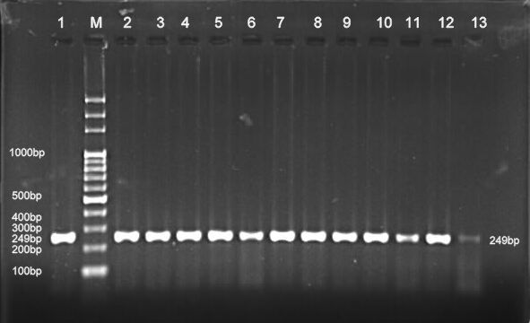

**Figure(1)** electrophoresis pattern of PCR product of IL-1β +3953 gene, the optimum annealing temperature was 55**o**C

**Genotype of IL-1β +3953** **gene polymorphism using PCR-RFLP**

Genotype of IL-1β +3953 gene polymorphism with Allele frequency between the two groups healthy and patient were detected using PCR-RFLP technique.

Results from figure (2) show the genotype of IL-1β +3953 gene in the two study groups healthy and patients (the healthy were 30 samples while the patients were 100 samples), TT homozygote represented (249 bp), CT heterozygote represented (249bp, 114bp and 135bp) and CC homozygote represented (135bp and 114 bp)

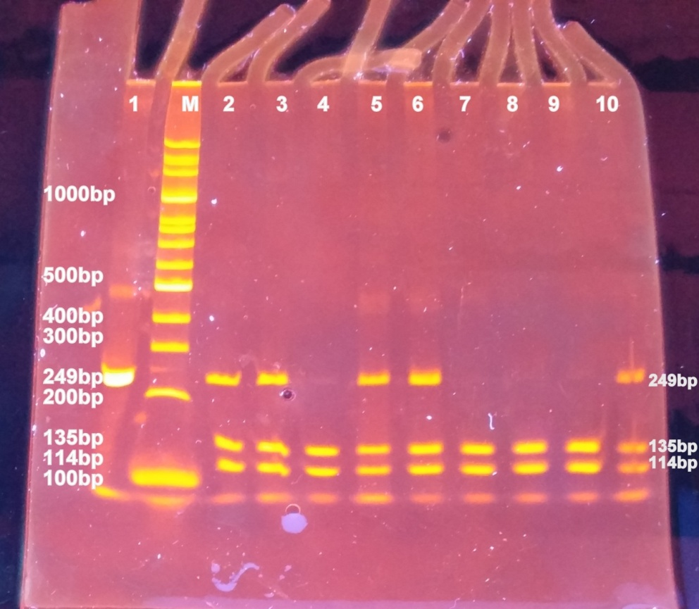

**Figure (2)** Electrophoresis pattern of IL-1β +3953 PCR-RFLP by 4% PAGE gel for PCR product (249bp) with restriction enzyme TaqI. Lane M DNA ladder.Lane (1): PCR product. Lane (2, 3, 5, 6, 10) heterozygote (CT) genotype, Lane (4, 7, 8, 9) homozygote (CC) genotype. ladder.Lane (1): PCR product. Lane (2, 3, 5, 6, 10) heterozygote (CT) genotype, Lane (4, 7, 8, 9) homozygote (CC) genotype.

Genotype frequencies of TT, CT , and CC of IL-1β +3953 gene polymorphism were 11(36.67%), 14(46.67%) and 5(16.66%) in the healthy group, while 17(17%), 48(48%) and 35(35%) in the patient group , table (7).

**Table(7) Genotype of IL-1β +3953** **gene polymorphism with Allele frequency**

|  |  |  |  |  |  |  |  |  |  |
| --- | --- | --- | --- | --- | --- | --- | --- | --- | --- |
| OR  CI 95% | *P* value | *χ2*  (1,N=130) | | | Patients | Healthy | | | Genotype IL-1β +3953 |
| 0.35 | 0.0036 | 6.673 | | | 17(17%) | 11(36.67%) | | | **TT** |
| 1.05 | 48(48%) | 14(46.67%) | | | **CT** |
| 2.69 | 35(35%) | 5(16.66) | | | **CC** |
| 100 | 30 | | | **Total number** |
| Allele frequency | | | | | | | | |
| Patient | | **Control** | | | | **Allele** | | |
| 0.41(41%) | | | 0.6(60%) | | | | **T** | |
| 0.59(59%) | | | 0.4(40%) | | | | **C** | |

Results from table(7) showed that the *P-value* of the genotype frequency of IL-1β +3953 gene in the two study groups was (0.0036) which is less than 0.05. So it was significant (p ≤0.05).

The data of allele frequencies of point mutations on IL-1β +3953 gene in two study groups were presented in Table (4.7) . For healthy group , allele frequency of (T) variant allele was 0.6 (60%), but( C) allele variant frequency was 0.4 (40%) according to Hardy- Weinberg equation.

While for patient group , allele frequency of (T) variant allele was 0.41 (41%), but (C) allele variant frequency was 0.59 (59%) according to Hardy- Weinberg equation, while the O.R. of each genotype were as showed in table (7). The strongest evidence for an association between IL-1 polymorphisms and periodontitis was provided by the study of Kornman *et al.,*1997. However, clinical studies investigating the functional role of the genotype have shown different results. The relationship between the genotype and the IL-1β levels in periodontitis is not yet fully understood. But we here gave a small idea about this relationship by estimation the concentration of IL-1β in saliva and serum . we found that the mean concentrations of IL-1β in saliva and serumof study groups were significant (*P* =0.024) in saliva and no significant mean difference of IL-1β (*P* =0.68) in serum between two groups. From these results we are concluded that significant association betweenperiodontitis on hands and polymorphism of IL-1β and their concentration in salivaon the other hand**.**

**Table (8) The mean of serum concentration of IL-1β and concentration** **in saliva and serum**

|  |  |  |  |  |
| --- | --- | --- | --- | --- |
| Concentration of IL-1β | Subjects | | T- test | *P* value |
| **Mean± SD** | |
| **Healthy pg/ml** | **Patient**  **pg/ml** |
| Saliva | 5.774 ± 11.57 | 31.037 ± 87.07 | 1.58 | 0.024 |
| Serum | 73.61 ± 142.66 | 76.48 ± 117.57 | 0.11 | 0.68 |

**References**

1. Pihlstrom, B. L., Michalowicz, B. S., and Johnson, N. W. (2005) Periodontal diseases, *Lancet 366*, 1809-1820.
2. Van Palenstein Helderman, W. H., Joarder, M. A., Bequm A., (1996). Prevalence and severity of periodontal disease and dental cariesin Bangladesh. *Int Dent J*. **46**: 76-81.
3. Loesche, W. J., and Grossman, N. S. (2001) Periodontal disease as a specific, albeit chronic, infection: diagnosis and treatment, *Clin Microbiol Rev 14*, 727-752,
4. Armitage, G. C. (2004) Periodontal diagnoses and classification of periodontal diseases, *Periodontol 2000 34*, 9-21.
5. Kinane, D. F., R. Attstrom, and European Workshop in Periodontology group B**.** (2005). Advances in the pathogenesis of periodontitis. Group B consensus report of the fifth European Workshop in Periodontology. J. Clin. Periodontol. **32**(Suppl. 6)**:**130–131.
6. Feng, Z., and A. Weinberg(2006). Role of bacteria in health and disease of periodontal tissues. Periodontol. 2000 **40:**50–76.
7. Graves, D. T., and D. Cochran(2003). The contribution of interleukin-1 and tumor necrosis factor to periodontal tissue destruction. J. Periodontol. **74:** 391–401.
8. Goutoudi, P., E. Diza, and M. Arvanitidou **(**2004). Effect of periodontal therapy on crevicular fluid interleukin-1beta and interleukin-10 levels in chronic periodontitis. J. Dent. 32:511–520.
9. MacFaddin, J.F. (2000). Biochemical Tests for Identification of Medical Bacteria. 3rd ed. Lippincott Williams and Wilkins, USA.
10. Darveau R.P., Tanner A. P. (1997). The microbial challenge in periodontitis. Periodontol. 2000 14:12-32.
11. Darveau R.P., Tanner A. P. (1997). The microbial challenge in periodontitis. Periodontol. 2000 14:12-32.
12. Ximenez-Fyvie L. A., Haffajee A. D., Socransky S.S.(2000). Comparison of the microbiota of supra- and subgingival plaque in health and periodontitis. J. Clin. Perriodonol. 27:648-657.
13. StatusWayne J. Millar, MA, MSc; David Locker.(2007). Smoking and Oral Health Status. JCDA .Vol.73, No. 2.
14. Kornman KS, Crane A, Wang HY, di Giovine FS, Newman MG, Pirk FW, Wilson TG JR, Higginbottom FL, Duff GW.(1997) The interleukin-1 genotype as a severity factor in adult periodontal

disease. J Clin Periodontol . 24: 72–77.

1. Mooney J, Hodge PJ, Kinane DF.( 2001). Humoral immune response in early-onset periodontitis: influence of smoking. J Periodontal Res; 36: 227–232.
2. Kugler, J., Hess, M., & Haake, D. (1992). Secretion of salivary immunoglobulin A in relation to age, saliva flow, mood states, secretion of albumin, cortisol, and catecholamines in saliva. J Clin Immunol, 12(1), 45-9.
3. Vining, R.F., McGinley, R., & Symons, R.G. (1983). Hormones in saliva: Mode of entry and consequent implications for clinical interpretation. Clin Chem, 29(10), 1752-56.
4. Joshi VM, Vandana KL. (2007).The detection of eight putative periodontal pathogens in adult and rapidly progressive periodontitis patients Indian J Dent Res;18:6-10.
5. Santtila S., Savinainen K., Hurme M.(1998). Presence of the IL-1RA allele 2 (IL1RN2) is associated with enhanced IL-1*B* production in *Vitro.* Scand. J .Immunol 47, 195-1998.
6. Chaitanya T., Vandana K. E.,1 Shashidhar A., Parvati B.,

Asha K., Shashidhar V., and Chiranjay M.( 2014) Prevalence of Clinical Periodontitis and Putative Periodontal Pathogens among South Indian Pregnant Women. International J. of Microbiology .Volume, Article ID 420149, 5 pages.